# Kennesaw State University

College of Computing and Software Engineering

Department of Computer Science

CS 5070, Mathematical Structures for Computer Science, Section W01

Assignment #1

Amrit Singh, [asingh59@students.kennesaw.edu](mailto:asingh59@students.kennesaw.edu)

06/05/2025

## Problem Statement

Purpose of this document is to solve the following problem set [1] for assignment #1. References will be noted in the reference section of this document and used in line denoted by brackets [].

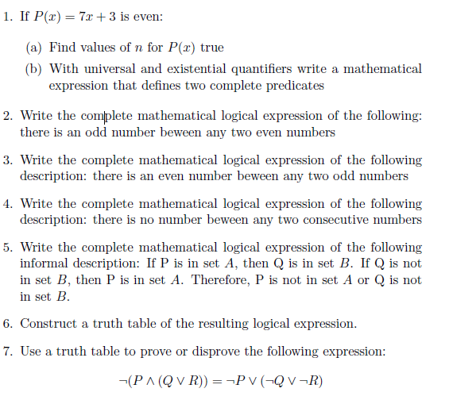

## Summary / Purpose

<Insert blerb on summary and purpose >

## Solutions

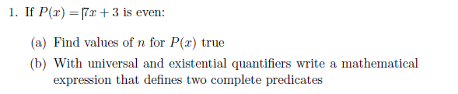

An even number x is defined as any x where x % 2 = 0, so P(x) = 7x + 3 = x % 2 = 0.



A = { }





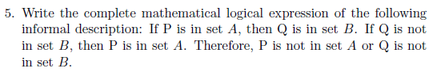



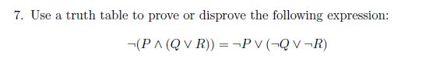

## Tables / Input Data & Results

<Don’t think this is needed??>

## References

[1] Kennesaw State University, College of Computing and Software Engineering, Department of Computer Science, Mathematical Structures for Computer Science. (n.d.). CS5070 Assignment 1. In *https://kennesaw.view.usg.edu/d2l/le/content/3550928/viewContent/55786667/View*.